Lab 3 Hadoop Setup on a Cluster

薛劭杰 1930026143 林晓涛 1930026081 马铭泽 1930006138

**Step1: Configuration Users**

Create a user and its file path for your host, then set password

Master:

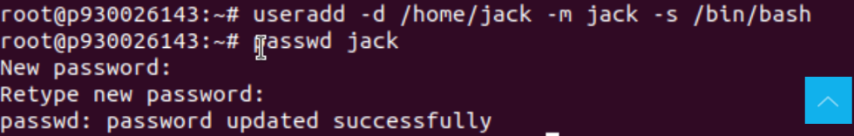

Slave1:

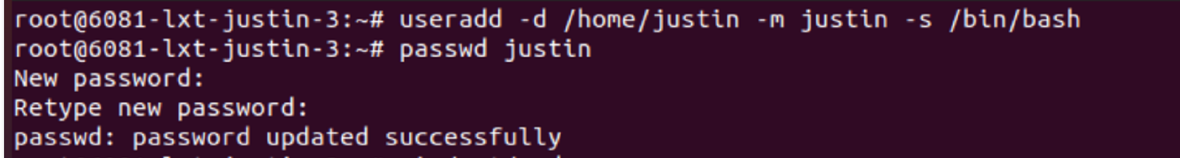

Slave2:



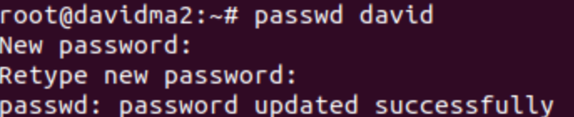

Add write permission to the file “sudoers”.

Add sudo permissions to the user.

Add the following line below “root”.

Master:



Slave1:



Slave2:





Delete the password and user privilege specification

Master:

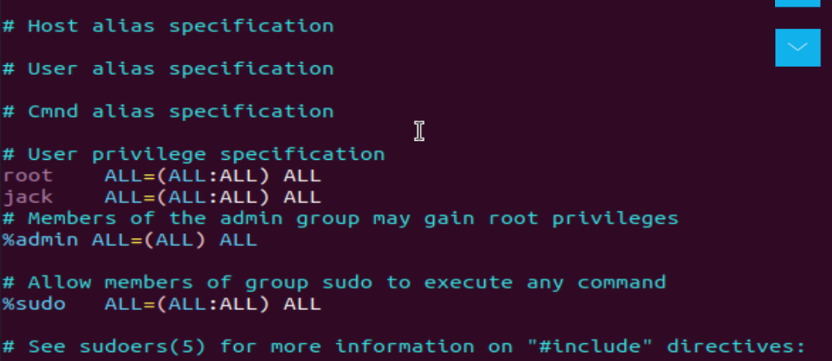

Slave1:

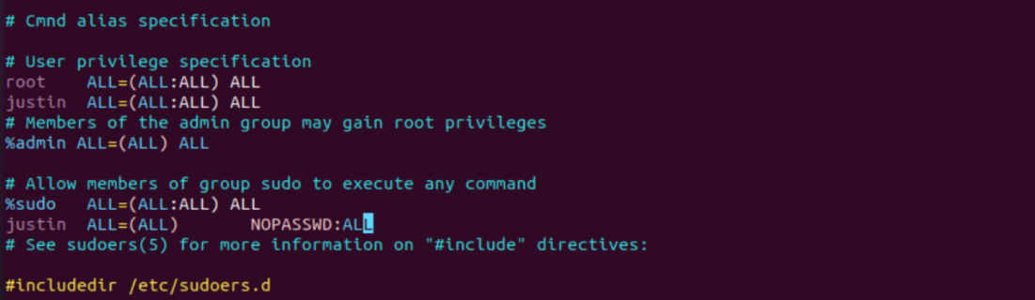

Slave2:

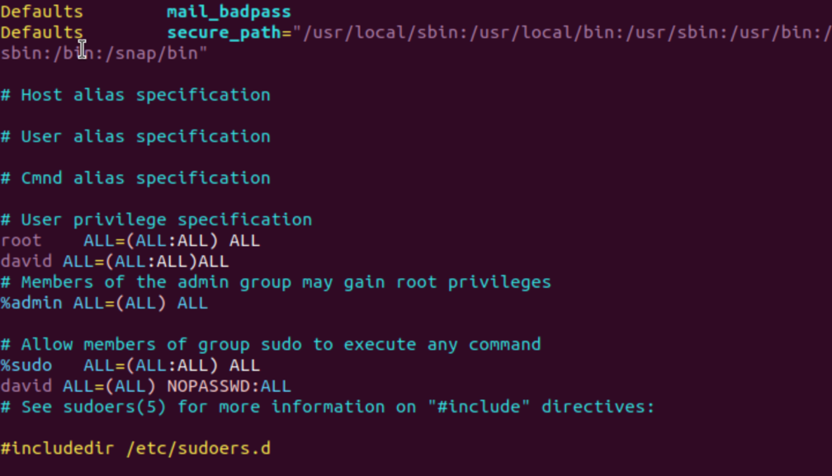

Then switch to the account to root and go to the root directary by this command on the master and slaves.

$\$ su$

$\$ cd \sim$

**Step2: Install Hosts**

Fistly get the public IP for three computers

Master:



Slave1:



Slave2:



Modify the file of hosts

Master:

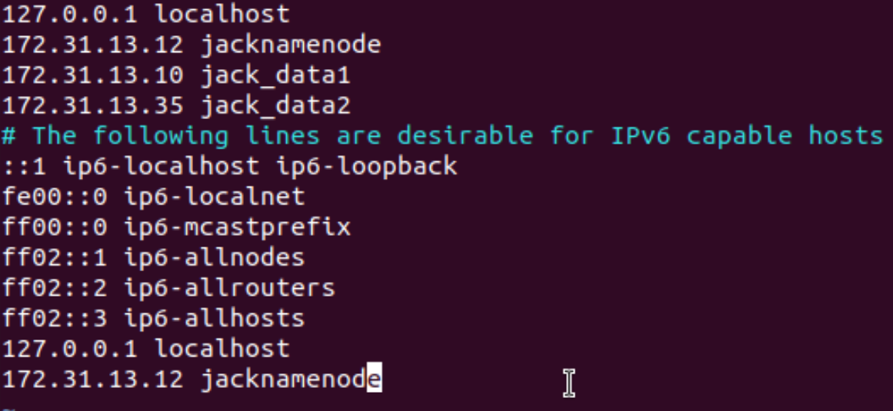

Slave1:



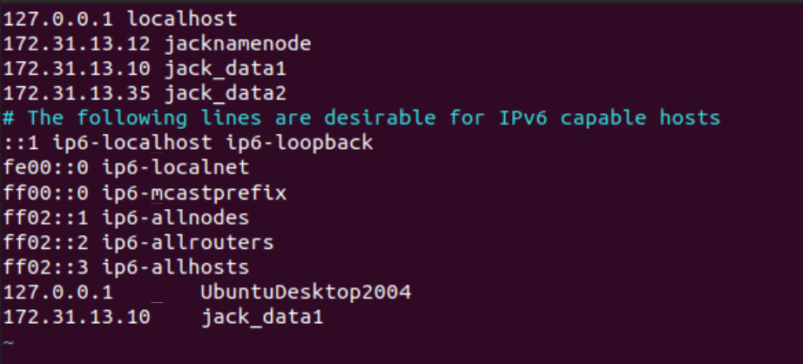

Slave2:

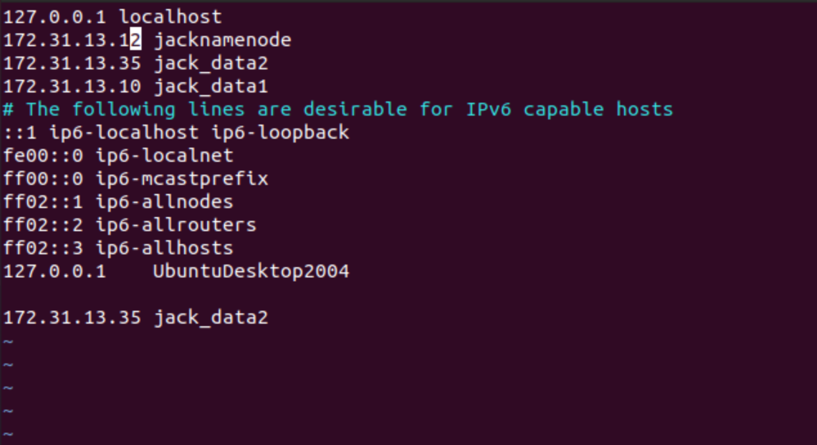

**Step3: Install JDK**

After updating the apt, then install jdk

Master:



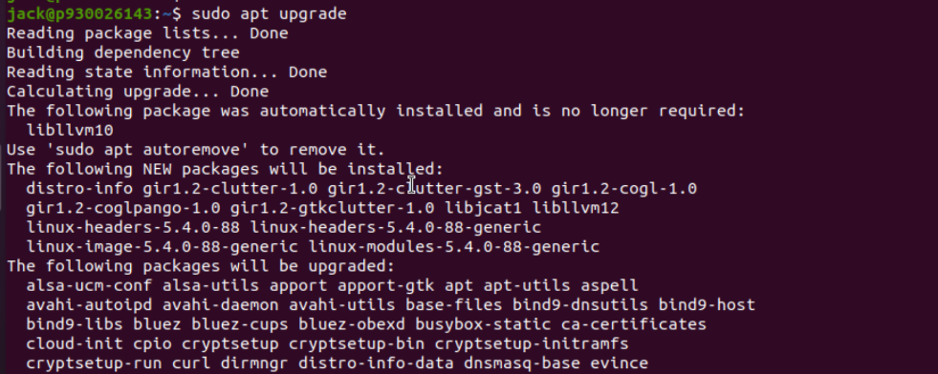

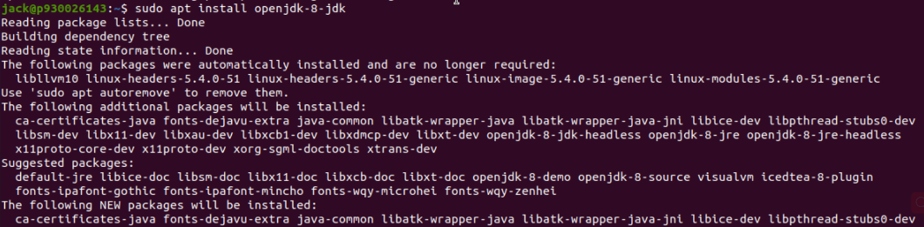

Slave1:



Slave2:

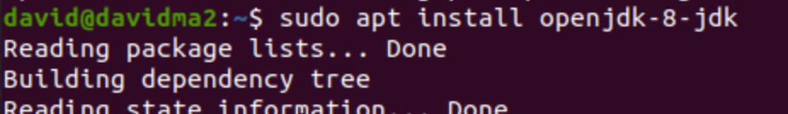

Modify the system file:

Master:

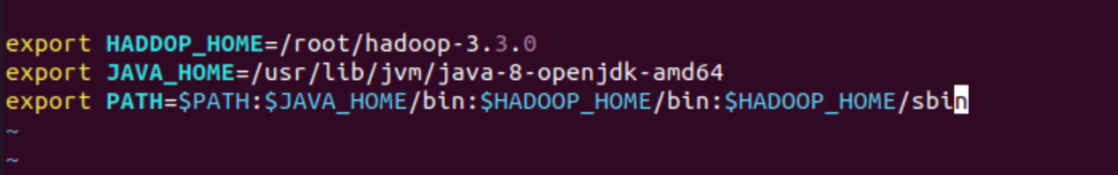

Slave1:

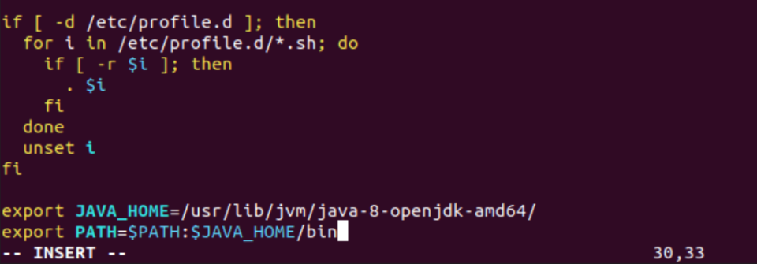

Slave2:

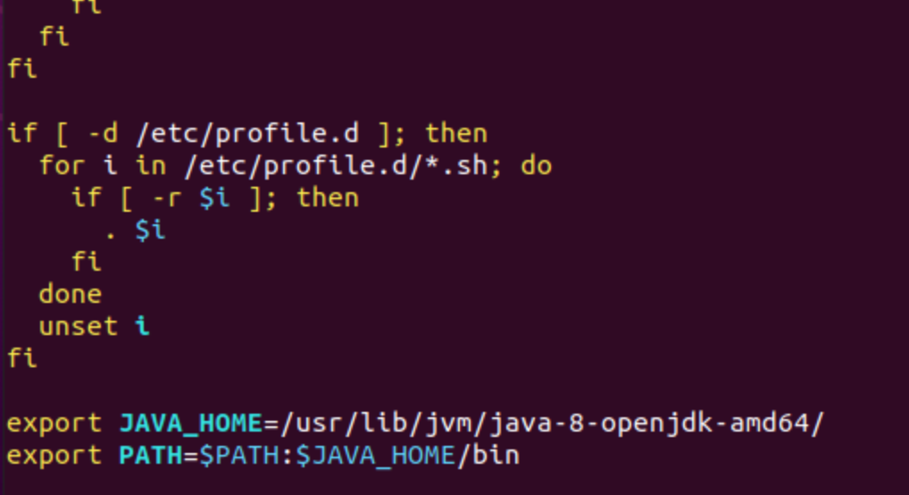

Test Java version

Master:



Slave1:

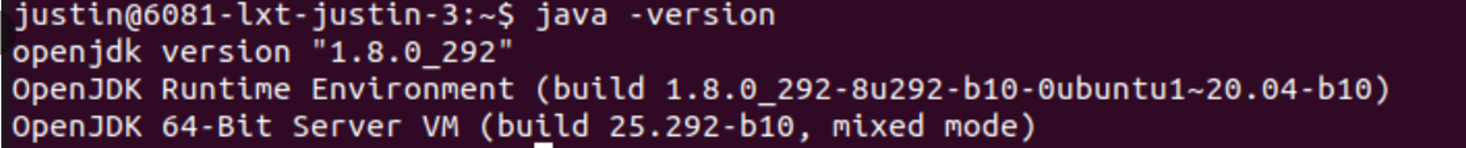

Slave2:

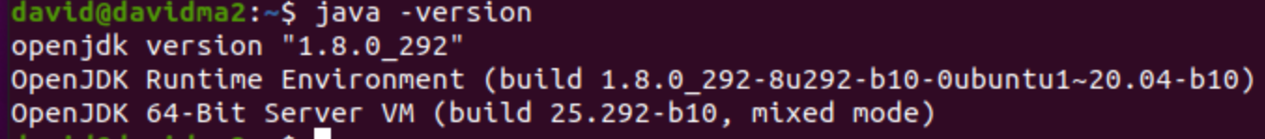

**Step 4: Set non - password login**

Generate the public key of SSH.

Master:

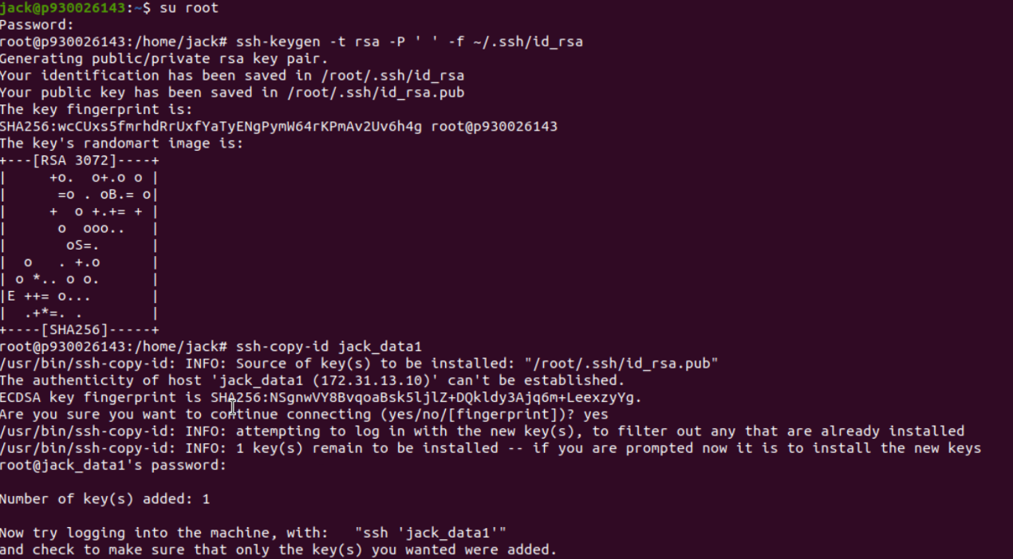

Slave1:



Slave2:

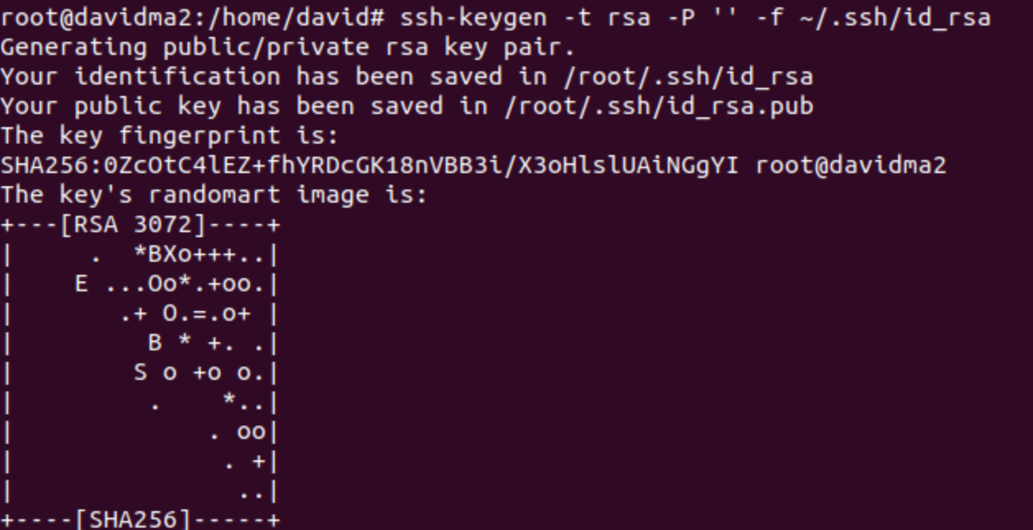

Copy and send files

Master:

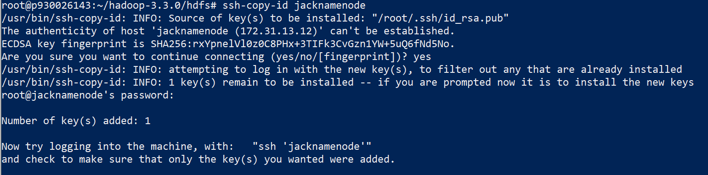

And share the key to slaves and localhost

$ ssh-copy-id jack_data1

$ ssh-copy-id jack_data2

$ ssh-copy-id localhost

Slave1:

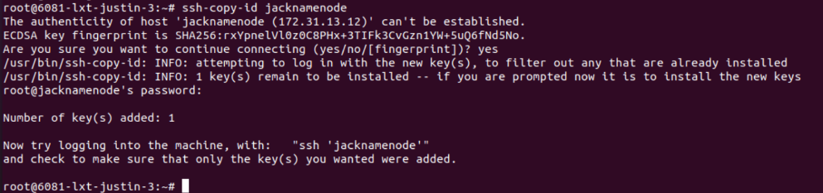

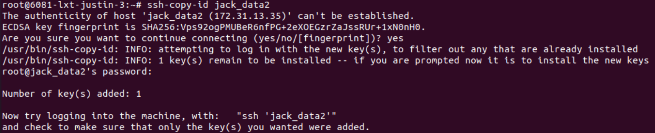

And share the key to master, another slave and localhost

$ ssh-copy-id jack_data1

$ ssh-copy-id localhost

Slave2:

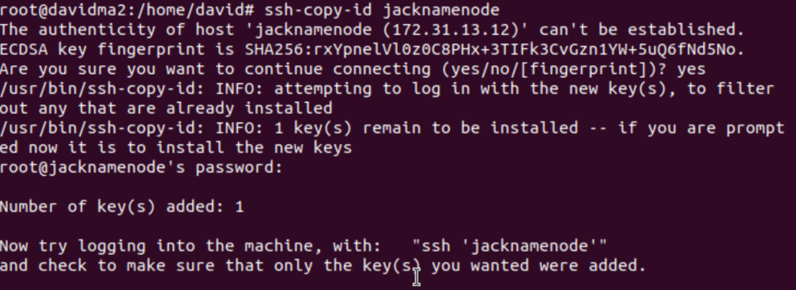

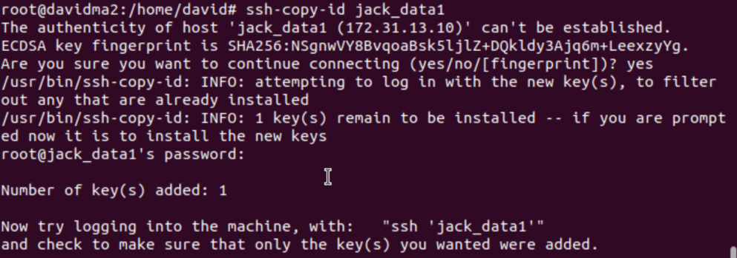

And share the key to master, another slave and localhost

$ ssh-copy-id jack_data1

$ ssh-copy-id localhost

**Step 5：Hadoop Settings**

Download hadoop

$ wget <https://mirrors.tuna.tsinghua.edu.cn/apache/hadoop/common/hadoop-3.3.0/>

**Step 6：Set Hadoop configuration files**

Setting the environment variables

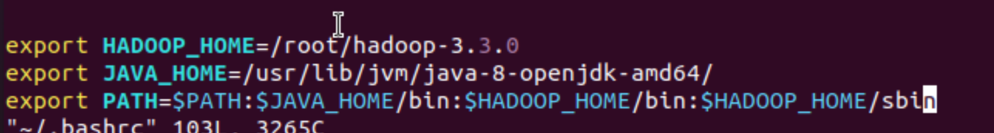

Modify hadoop-env.sh and yarn-env.sh



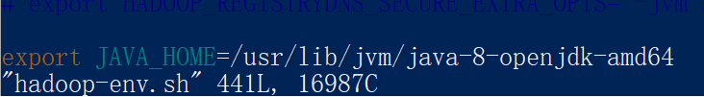

Modify core-site.xml

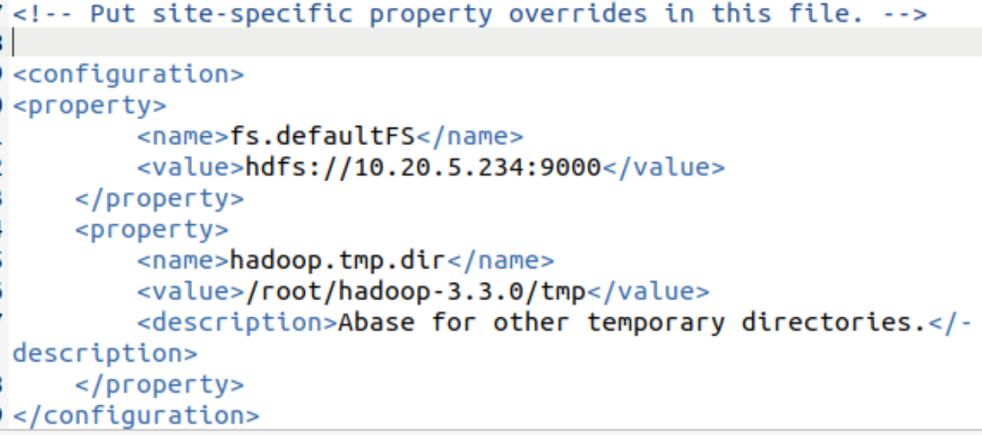

Modify mapred-site.xml 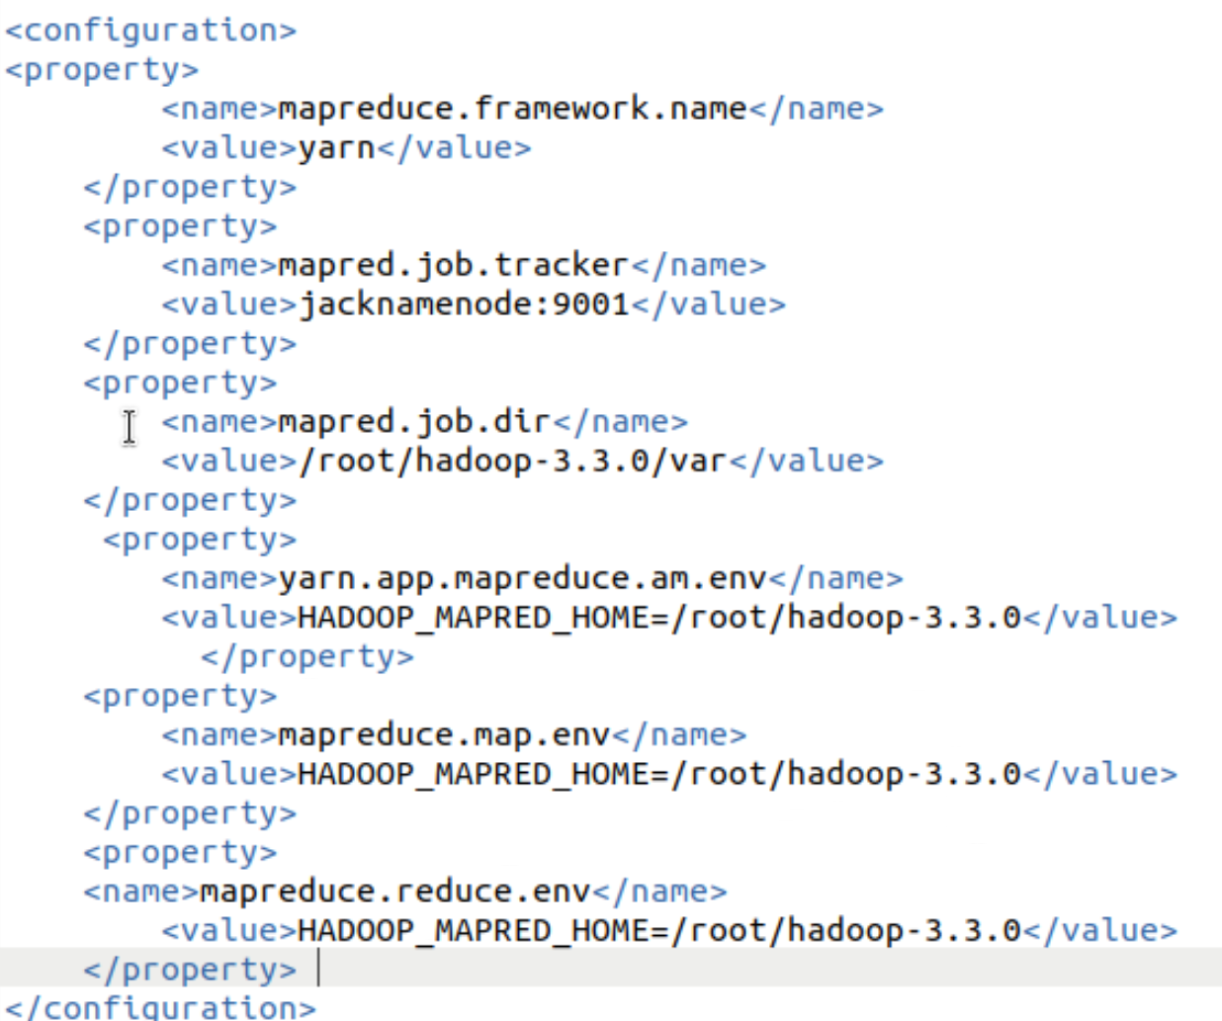

Modify hdfs-site.xml

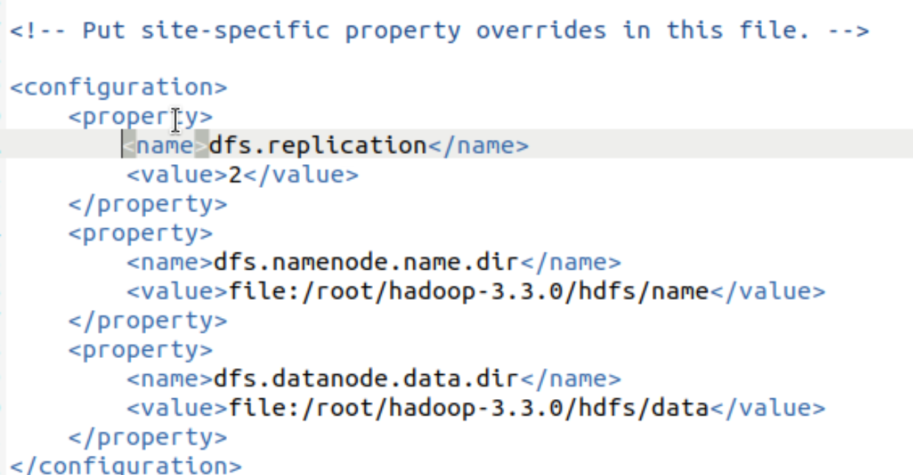

Modify yarn-site.xml

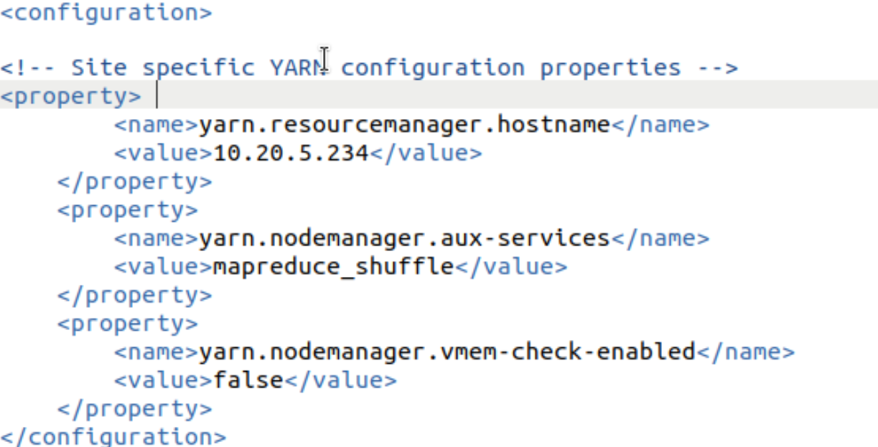

7, set salve node

Enter the workers file and add some information:

$sudo vi workers

jack_data1

jack_data2

Copy files to slaves

$ $ scp -r /root/hadoop-3.3.0/ root@jack_data1:~

$ scp -r /root/hadoop-3.3.0/ root@jack_data2:~

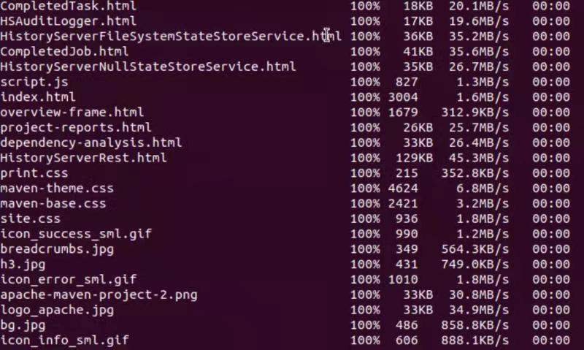

If the two can get the hadoop file, then it means sharing successfully.

Slave1:



Slave2:

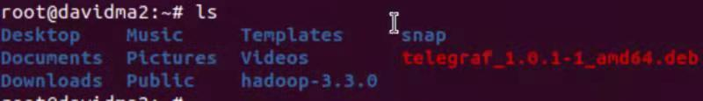

**Step 7： Test Hadoop**

1. Format distributed file system

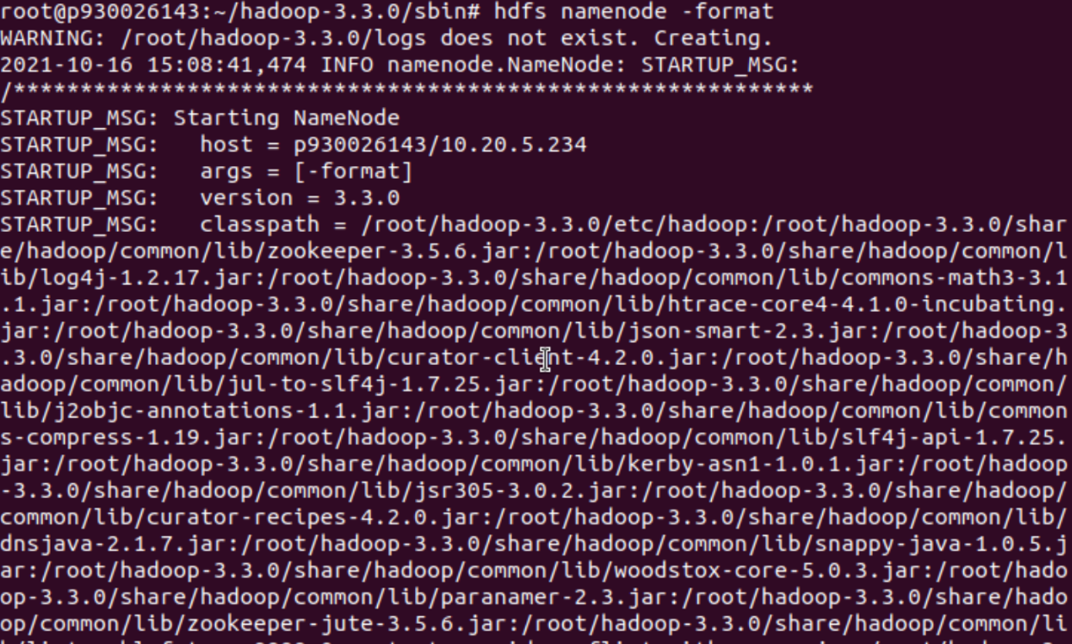

2. Set the yarn user permission in the fold /root/hadoop-3-3-0/sbin/

**Modify start-dfs.sh, stop-dfs.sh,add following lines in these two files.**

HDFS_DATANODE_USER=root

HDFS_DATANODE_SECURE_USER=hdfs

HDFS_NAMENODE_USER=root

HDFS_SECONDARYNAMENODE_USER=root

**Modify start-yarn.sh and stop-yarn.sh, add the following lines in these two files.**

YARN_RESOURCEMANAGER_USER=root

HDFS_DATANODE_SECURE_USER=yarn

YARN_NODEMANAGER_USER=root

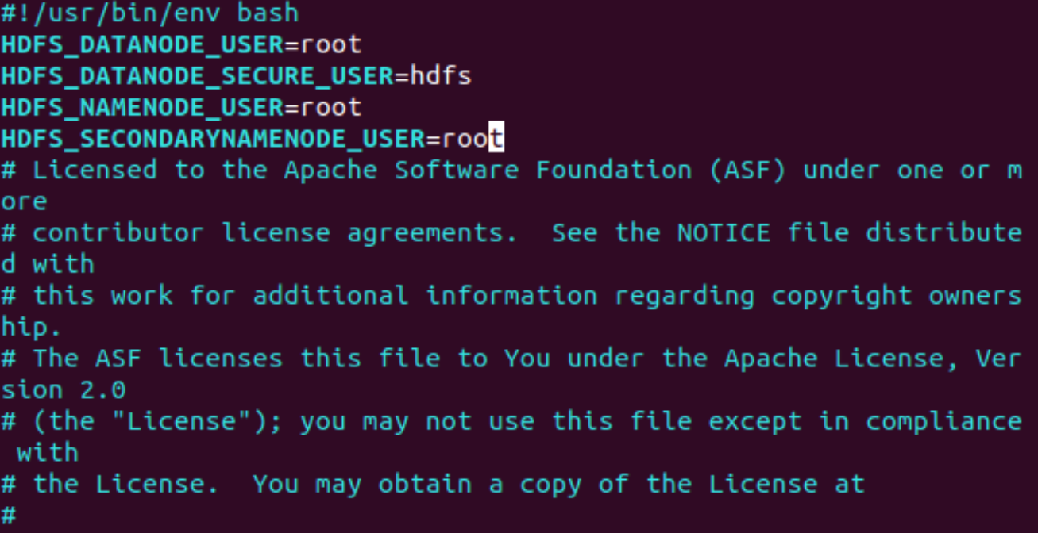

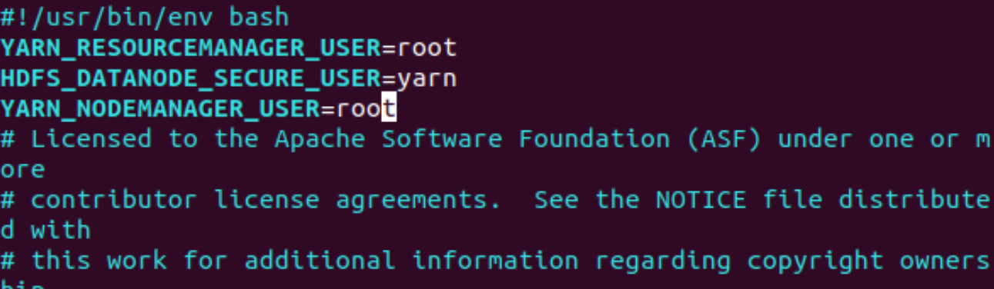

3. Start the programe of start-dfs.sh and start-yarn.sh

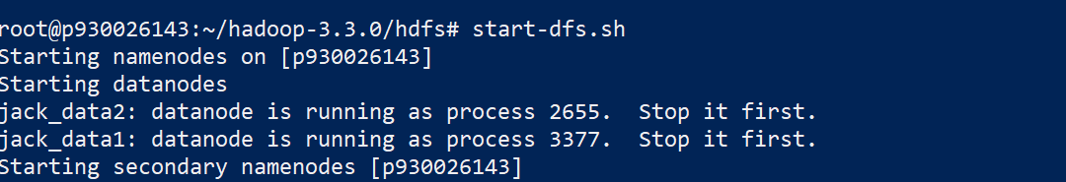

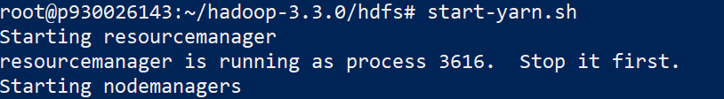

When encoutering the promblem of “DataNode cannot start” if we excute the command “hdfs namenode –format” more than once.

Do the following thing for all the machine

Remove all the content under the /root/Hadoop-3.3.0/hdfs



Do the following things on master host

Excute the $ hdfs namenode –format

Start the hadoop again 



DataNode start sucessfully

5. Test the commands of hdfs

Create the directories under HDFS



Upload some files to a specified directory and view the contents of the in directory on HDFS.

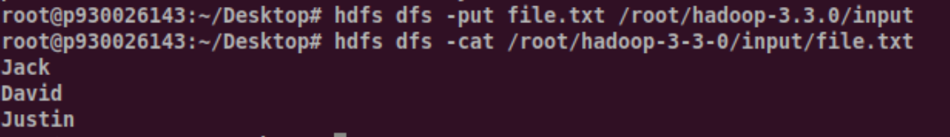

List the files under HDFS.



Get the file from HDFS. Simmiar to put, you can manipulate files and directories.

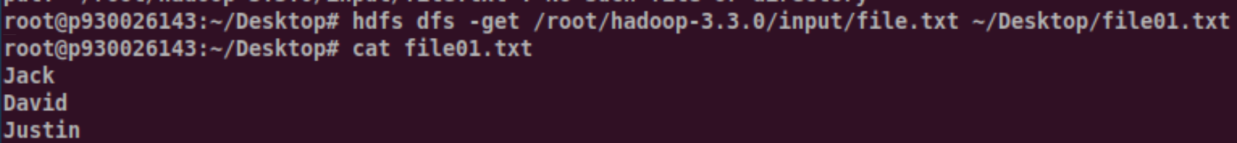

Delete the specified file from HDFS.



View basic statistics for HDFS.

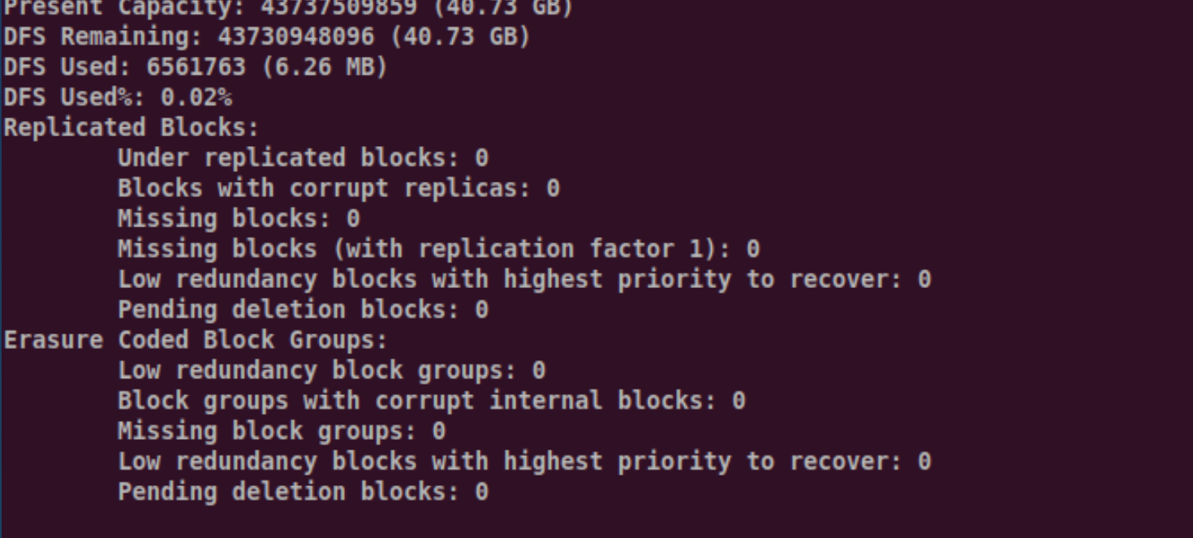

6. Web interface

After open the hadoop cluster, check the web-UI by

http://jacknamenode[:9870](http://master-123456:9870/)

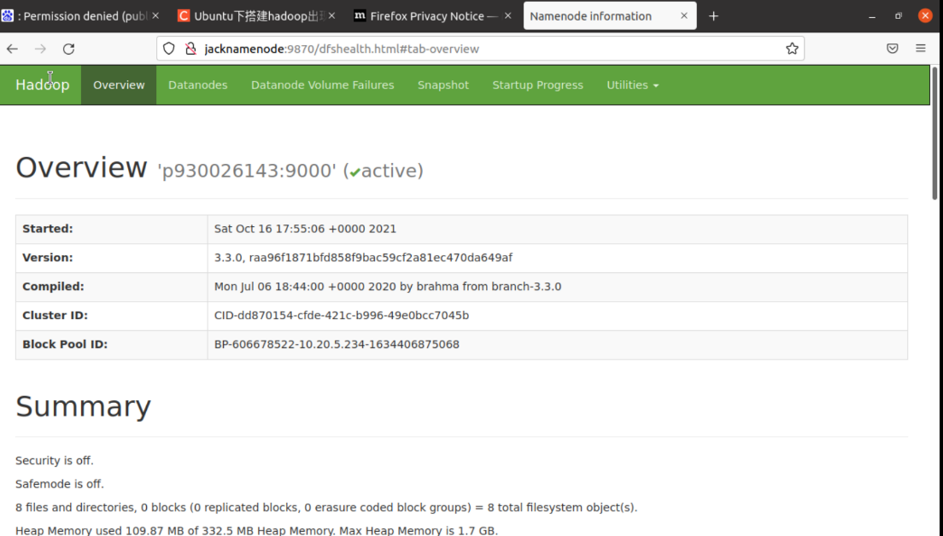

check the resource manager information

http:// jacknamenode[:8088](http://master-123456:8088/)

